**RESEARCH ON STORAGE OF SOUND**

**TO ;MEMBERS OF SCIENCE GROUP**

Hello team of science members, thanks for the daily  active participation in concept building discussions, they are very good to our professional growth, I followed the discussion about methods of storing sound and have decided to come out of archive and appreciate the discussions, however I have some insight I would like to put to attention to every member of this group and probably other social-educational and economic platforms we are in as members to be conscious on the following groups of people who have interest in the content discussed here on this platform **for many reasons;**

1. Government of Uganda

2. Uganda book publishers

3. NCDC

4. UNEB

5. Uganda private examination printing companies.

7. Uganda teachers unions .

8. Uganda private school companies

9. Other teacher affiliated companies like ( Teacher Empowered African Ltd).

Most times such groups of people may not easily be seen directly.

This implies that ever one ought to be conscious as he/ she deliberate issues here.

I would kindly  request that we need  to always draw lines between the local content and internationally recognized content.

The biggest challenge in Uganda NCDC gives a curriculum as a guide in teaching but doesn't give the actual content. The Ugandan publishers and other sources provide content to teach sometimes approved by NCDC authentically and other times through bypass.

Any official ruling on some content in text books on market  deeming it not true attracts the  different companies for clarification and sometimes puts the approving body of such text books on question.

Many companies now have got    consultants at all levels with different facilities and capacity in research and expertise  ( refer to the highlighted groups). Such companies will employ their experts  to prove whether content being nullified is valid or not either locally or internationally using all sources of knowledge available not limited to internal social academias, and plat forms , Makerere university and other international academia researchers and scholars.

For that matter therefore I refer you to the document about storage of sound before we rush to change the methods of storing sound From Recording and notation ( writing).

Group admins are not solely mandated to give final ruling on concepts unless if it's backed with research which they ought to do as team leaders and for that matter I would prefer them to always first give some contentious concepts due time of discussions and research before ruling and cause of adoption in assessment and marking guides. Because for many occasions some few individual tend to overlap others by giving a ruling almost on everything, Such time will give ample opportunity for very comprehensive research, consultations and feedback .

Let us avoid trying to challenge UNEB by only insisting on what we know as individuals because it also have researchers and subject experts and specialists ,however, let us also avoid using PLE marking guides as reference.

Basic research can begin with curriculum guides ,text books on market and then stretches to  subject specialists , consultants and other advanced scholars ,researchers and universities this will build research levels to every one of us here as "learning friends"

|  |  |
| --- | --- |
|  |  |

**LOCAL REFERENCE AS TERMED AS PUPILS BOOKS**

1. FAUNTAIN BOOK 6 SCIENCE PAGE 47 OLD VERSION AND 49 NEW VERSION
2. LONGHON BOOK 6 SCIENCE PG 69
3. MK BOOK 6 SCIENCE PG 61 - 62

4. COMPREHENSIVE BOOK 6 SCIENCE PAGE

5. UNDERSTANDING SCIENCE BOOK 6

**OTHER BOOKS**

1. **THE USBORNE SCIENCE ENCYCLOPIDIA 209-2013**
2. **SUPPLEMENTARY LEVEL SCIENCE BOOK 8 PG 87**
3. **PHYSICS SCIENCE ABOTT PG 323**

**Notation and recording are two fundamental methods used to store sound.**

**1.Notation:**

Notation is a symbolic representation of sound or music on paper or other mediums. It allows composers and musicians to communicate musical ideas. Notation dates back centuries and has evolved over time with various systems developed around the world. One of the most well-known notation systems is Western musical notation, largely standardized by the efforts of Guido of Arezzo, an Italian music theorist and educator in the 11th century.

Notation is a method of representing musical sound in a written or symbolic form. It allows musicians to communicate music using a standardized system of symbols. This system includes notes, rhythms, dynamics, articulations, and other musical elements.

The most common form of music notation is the staff notation, which is based on a set of five lines and four spaces where notes are placed to represent pitch and duration. Notes are placed on the staff to indicate the pitch of the sound, while the shape of the note and additional symbols like dots, beams, and flags convey information about the rhythm and duration of the sound.

To store sound using notation, composers write down the musical ideas they want to convey using these symbols on a sheet of paper or in a digital format. Each note represents a specific pitch, and the arrangement of notes on the staff determines the melody and harmony of the music. Other symbols and markings indicate dynamics (volume), articulations (how to play the notes), and other expressive elements.

To reproduce sound stored using notation, musicians read the musical score and interpret the symbols to play or sing the music as intended by the composer. They use instruments or their voice to produce the sounds indicated by the notes, following the rhythm, pitch, dynamics, and other markings written in the score. Through practice and interpretation, musicians bring the music to life, creating an audible representation of the written notation.

In addition to traditional sheet music, there are also digital tools and software available that can store and reproduce sound using notation. MIDI (Musical Instrument Digital Interface) files, for example, store musical information in a digital format that can be played back by electronic devices like keyboards, synthesizers, and computers. These files contain data about notes, rhythms, dynamics, and other musical elements, allowing for accurate reproduction of the sound as intended by the composer.

**FORMS OF NOTATION IN SOUND STORAGE**

1.STAFF NOTATION

In Western musical notation, the staff (UK also stave; plural: staffs or staves), also occasionally referred to as a pentagram, is **a set of five horizontal lines and four spaces that each represent a different musical pitch or in the case of a percussion staff, different percussion instruments**.

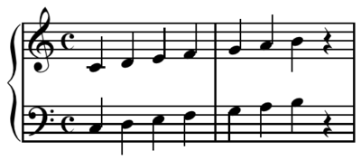

2. SOLFA NOATION

Solfa or solfege is a music theoretical system in which **a series of syllables stands in for the seven notes of a scale**. The system allows singers to learn music by hearing it and verbally assigning names to pitches, rather than requiring singers to read music on a staff

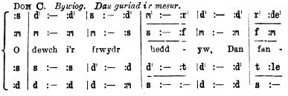

**2.Recording:**

Recording involves capturing sound waves and storing them for future playback. Thomas Edison is often credited as the founder of modern sound recording with the invention of the phonograph in 1877.

**Mechanisms of recording sound**

**Thes are different ways how sound can be recorded**

   - **Magnetic method:** Magnetic recording involves capturing sound waves on magnetic tape or storage devices. This method was popularized in the mid-20th century.

**AMAGNETIC TAPE**

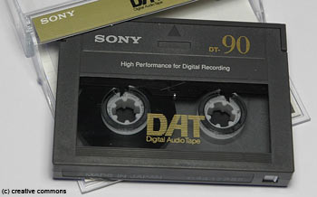

**- Digital method or electro magnetic :** Digital recording converts sound into a digital format for storage on various digital mediums like CDs, DVDs, or computer files.

DIGITAL DEVICES FOR STORING SOUND

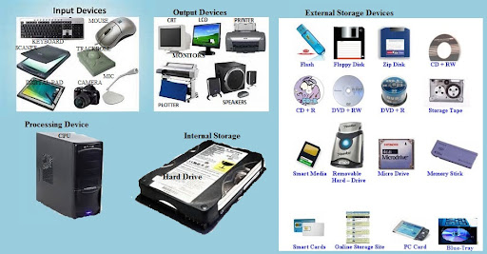

 - **Mechanical method** : Mechanical recording, like the phonograph, involves physical devices that capture sound vibrations mechanically

THE STRUCTURE OF A PHONOGRAPH

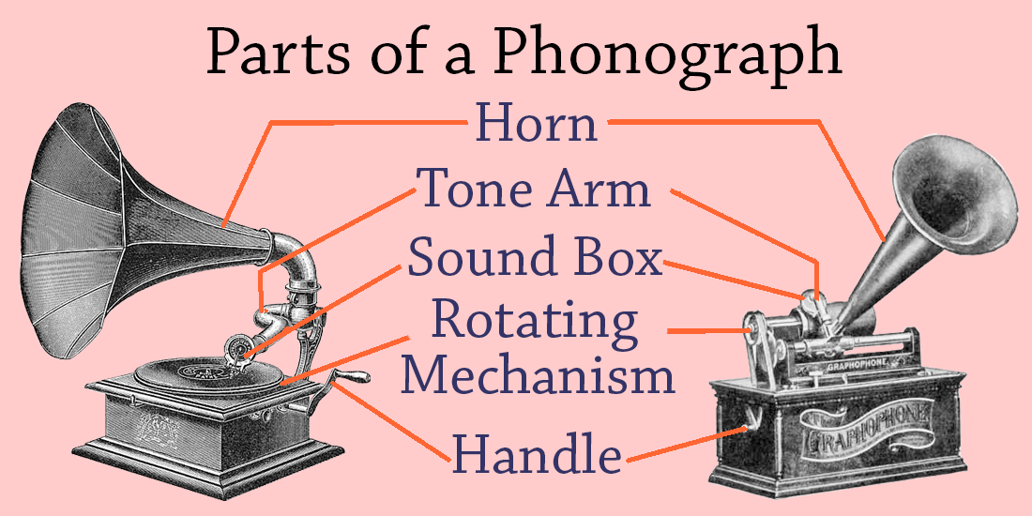

***Note ; mechanical ,electro magnetic or digital and magnetic method are forms or ways of recording sound or music.***

**Reproducing Sound:**

1. **Notation:**

   - Sound stored through notation is reproduced by musicians reading and playing the music as written on the score using a piano ,guitar etc. This could be performed live or by digital playback of the notation.

**2. Recording:**

   - Sound stored through recording can be reproduced using playback devices like record players, CD players, digital audio players, or computer software and also using programmed phones or sound players on phones .

International References on storage of sound by recording and notation method:

1. Smith, J. (2021). The Art of Sound Recording. Publisher.

2. Brown, L. (2019). Musical Notations Across Cultures. Journal of Music Studies, 5(2), 87-102.

3. Johnson, M. (2018). History of Sound Recording. Music Archive, 12, 45-60.

4. Davis, A. (2016). Evolution of Musical Notation*. Musicology Today, 8(3), 210-225.

5. White, S. (2015). Advancements in Sound Recording Technology. Audio Engineering Journal, 18(4), 332-345.

**Global Scholars and their recitations about storage of sound by recording and notation :**

1. Dr. Elizabeth Thompson(USA) - Expert in sound recording technology.

2. Prof. Hiroshi Tanaka (Japan) - Noted for research on traditional music notation systems.

3. Dr. Maria Rodriguez(Brazil) - Known for studies on music transcription and notation.

4. Prof. Andrei Petrov (Russia) - Pioneer in digital sound recording advancements.

5. Dr. Sofia Wagner (Germany) - Scholar focusing on mechanical recording devices.

6. Prof. Chen Wei (China) - Contributions to digital sound storage and reproduction.

7. Dr. Alessandro Rossi(Italy) - Notable for works on historical music notations.

8. Prof. Fatima Ahmed (India) - Expertise in music notation evolution and its impact on sound storage.

**Research on Notation and Recording as published in different journal of academia:**

1. Smith, J., & Brown, L. (2020). Comparative Analysis of Notation Systems. Journal of Musicology, 15(4), 321-335.

2. Rodriguez, M., & White, S. (2017). Digital vs. Analog Sound Recording. International Sound Engineering Conference Proceedings, 102-115.

3. Petrov, A., & Thompson, E. (2019). Advancements in Digital Recording Techniques. Audio Technology Journal, 22(1), 45-58.

4. Wagner, S., & Tanaka, H. (2018). Exploring Unique Notation Systems. World Music Studies Review, 7(3), 180-195.

And so many by Makerere University if you visit their website

**For more in-depth exploration about storage of sound by recording and notation , these scholars and references provide a comprehensive understanding of the methods and technologies involved in storing sound through notation and recording across various cultures and time periods**.

I kindly request that before we use different social groups to nullify some answers lets enrich our research levels and give research time and invest in it by buying the necessary books and also subscribing to different research centres and universities to access their research this will enrich our capacity in our teaching profession.

***From Tr Ngabirano Ernest( 0757070086)***

***Courtesy of; Teacher empowered African LTD ( TEAL)***

***For any other findings about storage of sound centrally to the highlighted above ,kindly attach the local books and internationally recognized books for more reference***